Workflow Functional Document

Application | NGERP - Centra
Workflow | Quote to Cash
Workflow Item Name | Accrual FOC

Description:

In Compiere ERP, Accrual FOC (Free of Charge) refers to a method for handling transactions where products or services are provided to customers without charge, but still need to be recorded for accounting, inventory, and financial reporting purposes

Workflow Process:

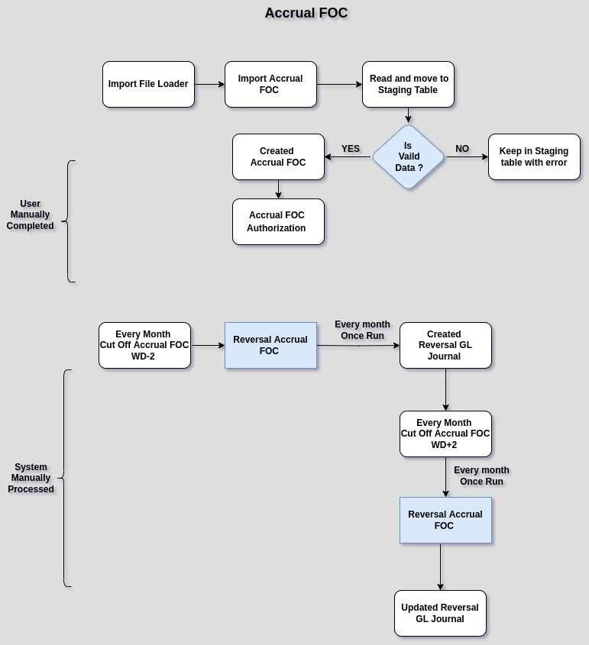

Business Rules:

- Import Accrual FOC file using the Import File Loader.
- The file name should starts and end with 'ImportAccuralFOC.csv.
- Import Data will be stored in the I_AccrualFOC staging table.
- During the import process, certain validations are performed, such as ensuring a valid business line, correct document type, active campaigns (that have not expired), currency type and Accrual FOC amount must not be empty and also Period must be opened.
- In case of an error during the import process, the import file will remain in the staging table with the 'NO' status. If no error occurs, it will move to the Accrual FOC screen.
- The user will manually complete the Accrual FOC transactions using either the Accrual FOC Authorization or the Batch Complete GL Journal process.
- The Accrual FOC transaction is created with the document type 'Unrecognized Revenue FOC' and 'Trade Discount Accrual.
- Accrual FOC Report shows the Status of the Transactions like Doc status,Date Invoiced,total amount,
Product , ISO Code,Print No, etc.
- During month-end (Cut Off WD-2), if any Accrual FOC (GL Journal) document is not completed, the
Reversal Accrual FOC scheduler process will run to create the reversal GL document.
- Every month (WD+2) Accrual FOC Re-post Scheduler will run and update the previous month reversal
Accrual FOC document and posted it .

